
Eco HABITS LOGGER
By Aaron Cairns


Contents
Overview of project 3
Requirements specification 3
Functional requirements 3
Non-functional requirements 3
Values for calculating feedback 4
User stories 4
Design specifications 4
Pseudocode 4
EcoHabitsApp (Main class); 4
EcoHabit; 6
MessageWriter; 7
Wireframe for program 9
Test Plan Overview 10
Purpose 10
Scope of Testing 10
Test Strategy 10
Username Input Validation – Normal Test Cases 11
Username Input Validation – Boundary Test Cases 11
Username Input Validation – Exceptional Test Cases 11
Eco Habit Daily Input – Normal Test Cases 12
Eco Habit Daily Input – Boundary Test Cases 12
Eco Habit Daily Input – Exceptional Test Cases 12
Performance Scoring Test Cases 12
File Output & Multi-User Test Cases 13
GUI & Navigation Test Cases 13
Deployment Instructions 13
Platform Requirements 13
Hardware Requirements 13
Operating System Requirements 13
Software Requirements 13
Supported File Types 14
Installation Instructions 14
Step 1 - Install Java 14
Step 2 – Install the Application 14
Step 3 – Running the Application 14
Step 4 – Using the Application 15
File Output Location 15
Uninstallation 15
Recommendations and Future Improvements 15
Code and JAR files 16

Overview of project

Requirements specification
The aim of this program is to help users monitor their weekly environmentally friendly habits and identify areas where they can improve. By providing scores and personalised feedback based on user input, the program encourages individuals to adopt more eco-friendly behaviours.
The intended audience includes people who are already environmentally conscious, as well as those who are interested in becoming more sustainable in their daily lives.
The program will include the following core features:
- The ability to recognise returning users.
- Tracking six different eco-friendly habits by asking users how many days per week they complete each action.
- Calculating an overall score based on the user’s responses.
- Providing feedback tailored to the user’s total score.
Overall, the program is designed to raise environmental awareness and motivate users to develop and maintain more sustainable habits.

Functional requirements
- Input weekly habit frequencies
- Validate inputs are whole numbers
- Calculate weekly total habits
- Identify the weakest habit
- Provide personalised improvement suggestions
- Calculating environmental and financial impacts
- Generate personalised weekly eco report
- Save report to a text file.
- Present report to the user

Non-functional requirements
- Clean, clear, accessible user interface
- Validate all input before calculations
- Clear and helpful error messages
- Consistent colour scheme (black & gold)
- Fast response time
- Platform independent (requires Java)
- Source code readability and maintainability

Values for calculating feedback
HABITS | PER DAY VALUES | SAVED PER DAY
Reusable water bottles | 1 Plastic bottle avoided | £1.00
Reusable coffee cups | 1 Disposable cup avoided | £0.30
Reusable shopping bag | 1 Plastic bag avoided | £0.10
Shorter showers | 1 Shorter shower (By 10 mins) | 90L of Water saved (£0.04)
Recycled items | 1 Item recycled | 0.5 kg of waste (£0.05)
Lights switched off | 1 Light turned off (5 hours off) | 0.05 kWh (£0.015)

* Each calculation for reusable items is based on pre-given document. Showers, recycling and lights are based on UK averages. *

User stories
- I want to record my eco-friendly habits so that I can monitor my progress over time.
- I want to receive personalised feedback so that I can understand which habits need improvement.
- I want to see both my environmental and financial impact.
- I want my results to be saved to a text file so that I can easily print or review them later.

Design specifications

Pseudocode

EcoHabitsApp (Main class);
START EcoHabitsApp

DISPLAY input dialog for username

IF name is empty OR cancelled
SET username to "Guest"
END IF

CREATE main window and apply layout, colours, and title

CREATE array of EcoHabit objects
CREATE array of text fields for user input

DISPLAY heading "How many times per day?"

FOR each EcoHabit
DISPLAY habit icon and name
DISPLAY input field
END FOR

DISPLAY "Calculate My Impact" button
WAIT for button click

INITIALISE totals, error flags, and weakest habit tracking

FOR each EcoHabit
READ input value
IF value is not a valid whole number OR is negative
ADD error message
SET error flag
ELSE
STORE value
UPDATE totals and weakest habit
END IF
END FOR

IF errors exist
DISPLAY error dialog
STOP processing
END IF

DETERMINE performance rating from total daily habits

CONVERT daily values → weekly → yearly
CALCULATE environmental and financial impact

BUILD personalised report text

SAVE report using MessageWriter
DISPLAY report to user

END EcoHabitsApp

EcoHabit;
FUNCTION getName
RETURN habit name
END FUNCTION

FUNCTION setTimes(value)
STORE value as times completed per day
END FUNCTION

FUNCTION getTimes
RETURN times completed per day
END FUNCTION

FUNCTION getTip
RETURN habit tip
END FUNCTION

FUNCTION getIcon
RETURN habit image icon
END FUNCTION

END EcoHabit

MessageWriter;
START writeToFile(userName, message)

DETERMINE directory where the application (JAR) is running
SET reportsFolder to "Reports" inside application directory

IF reportsFolder does not exist
CREATE reportsFolder
END IF

GENERATE unique report file name using username and timestamp

OPEN report file for writing

WRITE report header including:
- User name
- Current date and time

WRITE full report message content

WRITE report footer

CLOSE file

IF error occurs
DISPLAY error message to console
END IF

END writeToFile

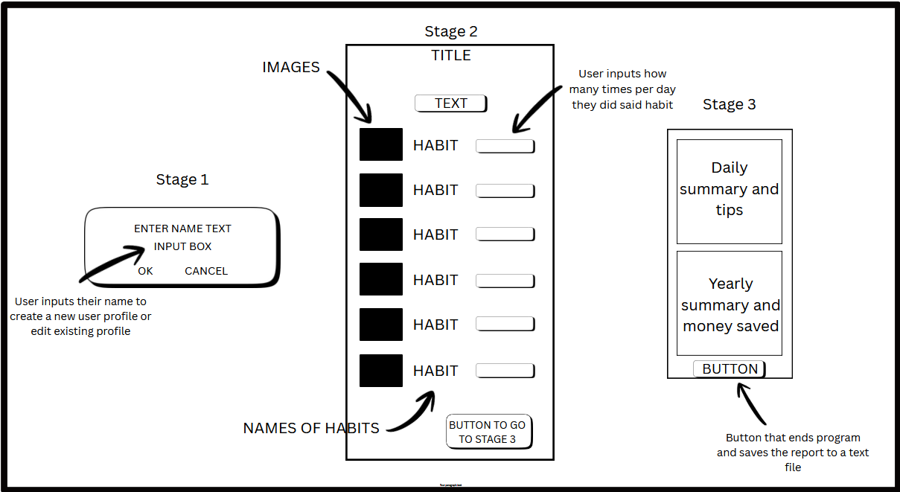
Wireframe for program

Test Plan Overview

Purpose
The purpose of this test plan is to define what will be tested, how it will be tested, and what data will be used to ensure the Eco Habits Tracker application works as intended.
The testing focuses on:
- Correct user input handling
- Accurate calculations
- Error handling
- Multi-user functionality

Scope of Testing
The following areas will be tested:
- Username input
- Daily habit input validation
- Performance scoring logic
- Environmental and financial calculations
- GUI interaction and usability

Test Strategy
Testing will be carried out using:
- Manual testing
- Structured test cases
- Normal, boundary, and exceptional data
Each test will compare:
- Expected results vs actual results

Test Environment
- Operating System: Windows 10 / Windows 11
- Java Version: Java 21
- Application Type: Java Swing GUI (.JAR)
Tester: Aaron Cairns
Date: 16/12/2025

Username Input Validation – Normal Test Cases
Test Description | Input Data | Expected Result | Actual Result | Pass/Fail
Valid lowercase name | aaron | Name accepted, main screen loads | ✔ | PASS
Valid uppercase name | AARON | Name accepted, main screen loads | ✔ | PASS
Valid mixed-case name | AaRoN | Name accepted, main screen loads | ✔ | PASS

Username Input Validation – Boundary Test Cases
Test Description | Input Data | Expected Result | Actual Result | Pass/Fail
Single character name | A | Name accepted, app loads | ✔ | PASS
Very long name | BartholomewMontgomerySmith | Name accepted, no crash | ✔ | PASS

Username Input Validation – Exceptional Test Cases
Test Description | Input Data | Expected Result | Actual Result | Pass/Fail
Cancel input | Cancel dialog | Defaults to Guest | ✔ | PASS
Empty input | "" | Defaults to Guest | ✔ | PASS

Eco Habit Daily Input – Normal Test Cases
Test | Input Data | Expected Result | Actual Result | Pass/Fail
Mixed valid inputs | 1,2,1,3,1,2 | Accepted, calculations run | ✔ | PASS
Single habit tracked | 1,0,0,0,0,0 | Accepted, report generated | ✔ | PASS
Moderate usage | 2,2,2,2,2,2 | Accepted, report generated | ✔ | PASS

Eco Habit Daily Input – Boundary Test Cases
Test | Input Data | Expected Result | Actual Result | Pass/Fail
All zero values | 0,0,0,0,0,0 | Accepted, tips shown | ✔ | PASS
High daily values | 10,10,10,10,10,10 | Accepted, large yearly totals | ✔ | PASS

Eco Habit Daily Input – Exceptional Test Cases
Test | Input Data | Expected Result | Actual Result | Pass/Fail
Negative number | -1 | Error message shown | ✔ | PASS
Non-numeric input | abc | Error message shown | ✔ | PASS
Multiple invalid inputs | abc, -2, "" | All errors listed | ✔ | PASS

Performance Scoring Test Cases
Test | Input Data | Expected Result | Actual Result | Pass/Fail
Low activity score | Total ≤ 4 | Starting your eco journey | ✔ | PASS
Medium activity score | Total 5–10 | You're doing great | ✔ | PASS
High activity score | Total > 10 | Very eco-conscious | ✔ | PASS

File Output & Multi-User Test Cases
Test | Input Data | Expected Result | Actual Result | Pass/Fail
First-time user | Aaron | Report file created | ✔ | PASS
Same user again | Aaron | Report appended | ✔ | PASS
Different user | Natasha | Separate report file | ✔ | PASS
Reports folder missing | Delete folder | Folder recreated | ✔ | PASS

GUI & Navigation Test Cases
Test | Input Data | Expected Result | Actual Result | Pass/Fail
Launch application | Run JAR | Name dialog appears | ✔ | PASS
Calculate impact | Click button | Report shown | ✔ | PASS
Close window | Click X | App exits cleanly | ✔ | PASS
Resize window | Resize attempt | Minimum size enforced | ✔ | PASS

Deployment Instructions

Platform Requirements

Hardware Requirements
- Desktop or laptop computer
- Minimum 4 GB RAM
- At least 100 MB of free disk space

Operating System Requirements
- Windows 10 or Windows 11
(Application has been tested on Windows systems)

Software Requirements
- Java Runtime Environment (JRE) 21 or later
- No additional third-party libraries required

Supported File Types
- Executable JAR file (.jar)
- Text files (.txt) for report storage

Installation Instructions

Step 1 - Install Java
- Visit the official Oracle Java website or an OpenJDK distribution (e.g. Adoptium).
- Download Java 21 (JRE or JDK) for Windows.
- Run the installer and follow on-screen instructions.
- Confirm installation by opening Command Prompt and typing - java -version
- Ensure Java 21 or later is displayed.

Step 2 – Install the Application
- Copy the EcoHabitsApp.jar file to a folder of your choice (e.g. Desktop).
- No additional installation steps are required.

Step 3 – Running the Application
Option 1 – Double-click
- Double-click EcoHabitsApp.jar.
- The application will launch and prompt for a username.
Option 2 – Command Line
- Open Command Prompt.
- Type java -jar EcoHabitsApp.jar (Command prompt will automatically search “C:\Users\NAME OF USER” for the file so if the directory doesn’t match this, find the JAR file and click on the directory above until highlighted then type CMD into the highlighted directory and this will create a search path for the JAR file to which retype java -jar EcoHabitsApp.jar)

Step 4 – Using the Application
- Enter a username when prompted.
- Input daily eco habit values.
- Click “Calculate My Impact”.
- View the generated report on screen.
- A report file is automatically saved in a “Reports” folder next to the JAR file.

File Output Location
- A folder named Reports is created automatically in the same directory as the JAR file.
- Each user has their own report file named:
- EcoHabitReport_<Username>.txt
- Reports are appended so multiple sessions are preserved.

Uninstallation
- Delete the EcoHabitsApp.jar file.
- Delete the Reports folder if no longer required.
- No system changes remain after removal.

Recommendations and Future Improvements

During the development of the Eco Habits Tracker, I identified several areas where the application could be improved in the future. While the current version meets all functional requirements, there are opportunities to enhance usability, accuracy, and functionality.
In future versions, I would improve data storage by using a database instead of text files. This would allow users to store long-term habit data and track progress over time. I would also improve user identification by introducing unique usernames or optional passwords to prevent duplicating user records.
Another improvement would be adding graphical displays, such as charts, to visually show eco impact and savings. This would make the results easier to understand and more engaging for users. I would also allow users to customise environmental values, such as energy or water costs, to improve the accuracy of calculations
One challenge I encountered was managing Java version compatibility and ensuring the JAR file worked correctly across different systems. Handling file locations for saved reports was also challenging, which highlighted the importance of careful testing and deployment planning.
Overall, these improvements would make the application more robust, user-friendly, and scalable in the future.

Code and JAR files

